Infosys Springboard Virtual Internship 6.0 Completion Report
Batch Number :- I
Start date :- 11/08/2025
Names: Siddharth Singh , Agam Indravarshit , Navendu Ojha , Suresh Koyyana , Sai Pranav , Ayush Kumar , Arun S
Internship Duration: 8 Weeks

1. Project Title
BudgetWise AI Driven Expense Tracker and Budget Advisor

2. Project Objective
The primary objective of this project was to develop a comprehensive tool for individuals to manage their finances effectively amidst increasing financial uncertainty and the need for better money management. The application aimed to provide a personalized dashboard to record, analyze, and manage financial transactions while supporting community interaction.

3. Project description in detail
The project is BudgetWise AI Driven Expense Tracker and Budget Advisor designed to give users a clear overview of their finance .
- Approach: We developed the application in a modular fashion over an 8-week period. The core approach was to create a secure, user-friendly platform with distinct features for tracking transactions, setting budgets, visualizing financial data, and fostering a community for financial advice. The execution followed a systematic workflow, starting from the user interface, which communicates with the backend via API calls, processes business logic, and interacts with the database for storage.
- Technology Used: The application's backend was built on Java, handling business logic and authentication. A JWT-based system was implemented for secure user registration and login, ensuring role-based access for users and administrators. On the front-end, API calls were managed using Axios to communicate between the user interface and the backend services. The database schema was designed to handle users, transactions, budgets, savings goals, and forum data efficiently.
- Real-World Impact: In a world where financial literacy is crucial, this web app provides a practical solution for better money management. It helps users understand their spending habits through graphical visualizations , stick to budgets , and achieve their savings goals.

4. Timeline Overview
Week | Activities Planned | Activities Completed
Week 1 | User Registration And User Authentication | Done
Week 2 | Login And Profile Management | Done
Week 3 | Adding Expense and Income to Profile | Done
Week 4 | Tracking of Expense and Income | Done
Week 5 | Budget and Savings Goals | Done
Week 6 | Financial Trends and Visualization | Done
Week 7 | Export & Community Forum | Done
Week 8 | AI Bot to Communicate And Provide Suggestions to User | Done

5a. Key Milestones
Milestone | Description | Date Achieved
Project Kickoff | Official start of the project and finalization of requirements. | 11/08/2025
Prototype/First Draft | Login, registration, and profile setup were fully operational | 25/08/2025
Mid-Term Review | Users could successfully record, edit, and view categorized financial transactions | 08/09/2025
Final Submission | All core features, including data visualization, export, and the community forum, were implemented and tested. | 06/10/2025
Presentation | A final presentation demonstrating the web app's functionality and outcomes. | 06/10/2025

5b. Project execution details
The project was executed by following the planned, week-wise module implementation schedule. The team adopted a layered architectural approach as detailed in the workflow diagram:
- User Interface (UI): The process begins at the UI, where the user interacts with the application.
- API Layer: The UI communicates with the backend through API calls via Axios.
- Backend Logic: The backend handles all business logic, including user authentication and transaction processing.
- Database: All data is securely stored in a database, which interacts with the backend to retrieve or store information.
- External Services: Optional integrations, such as Ollama AI, were handled as external services.

6. Snapshots / Screenshots
Backend Code
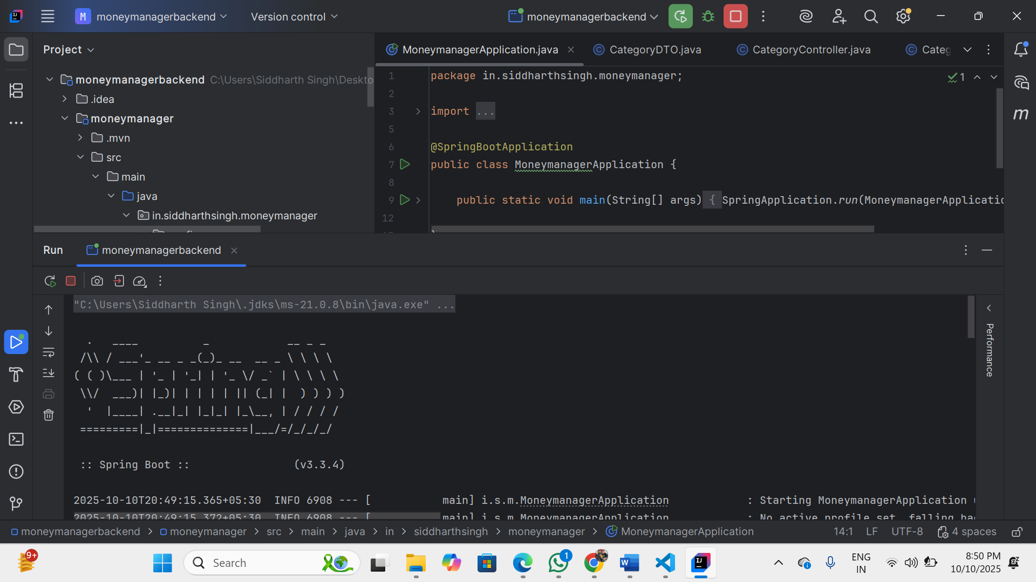
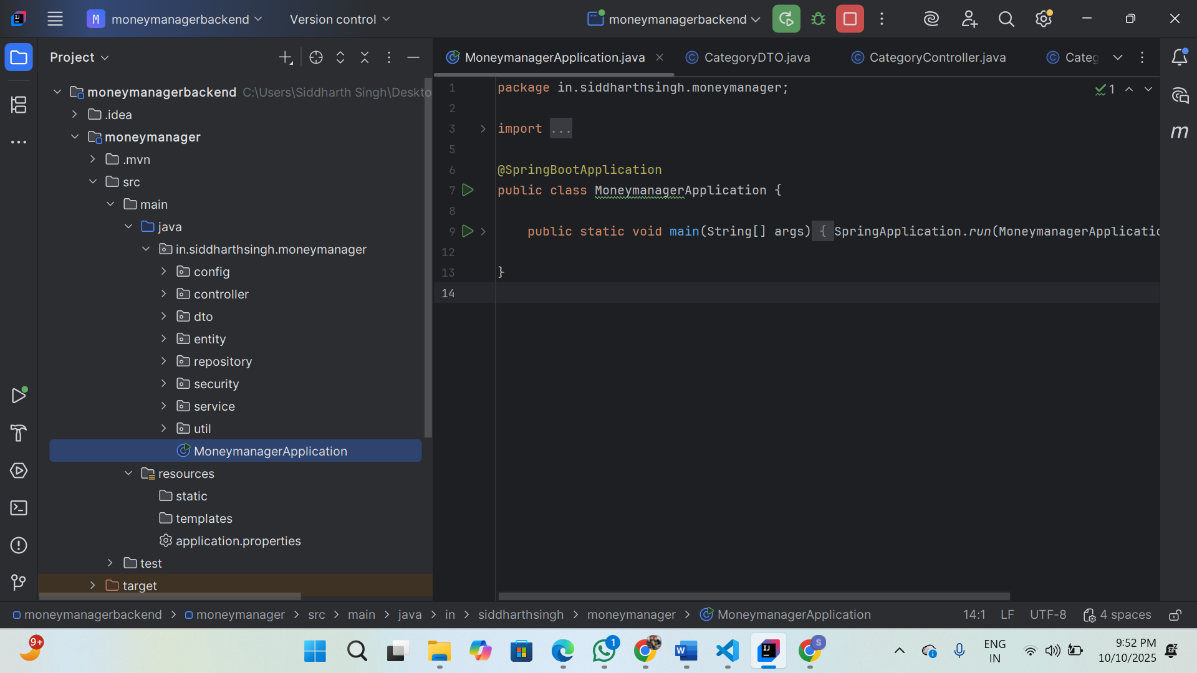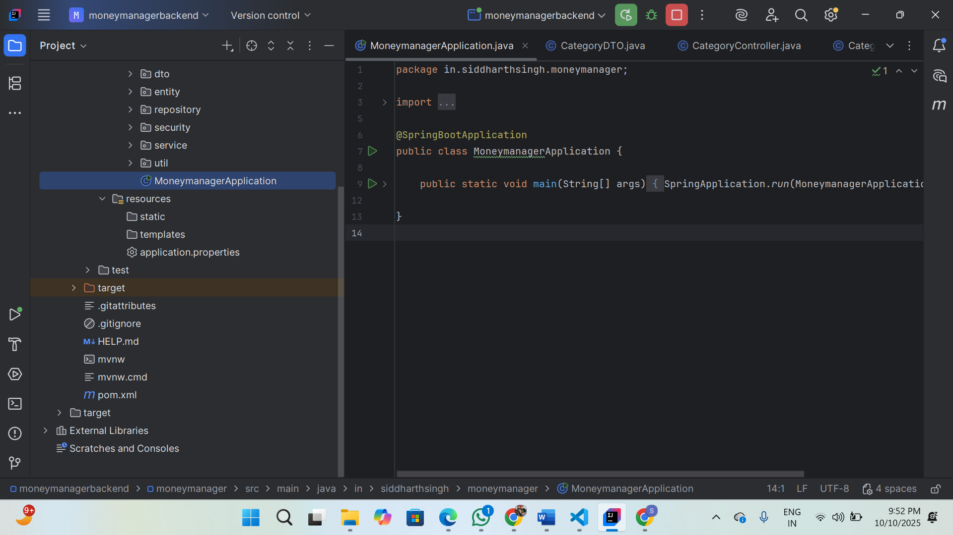
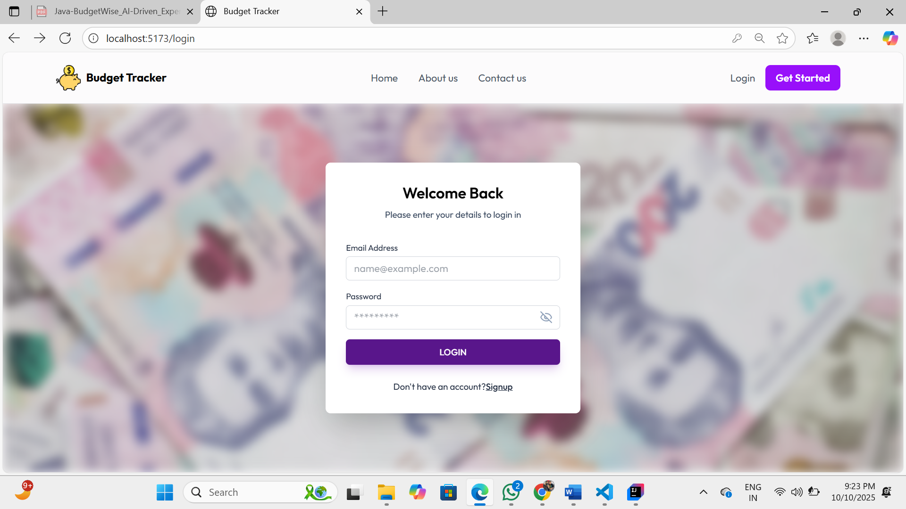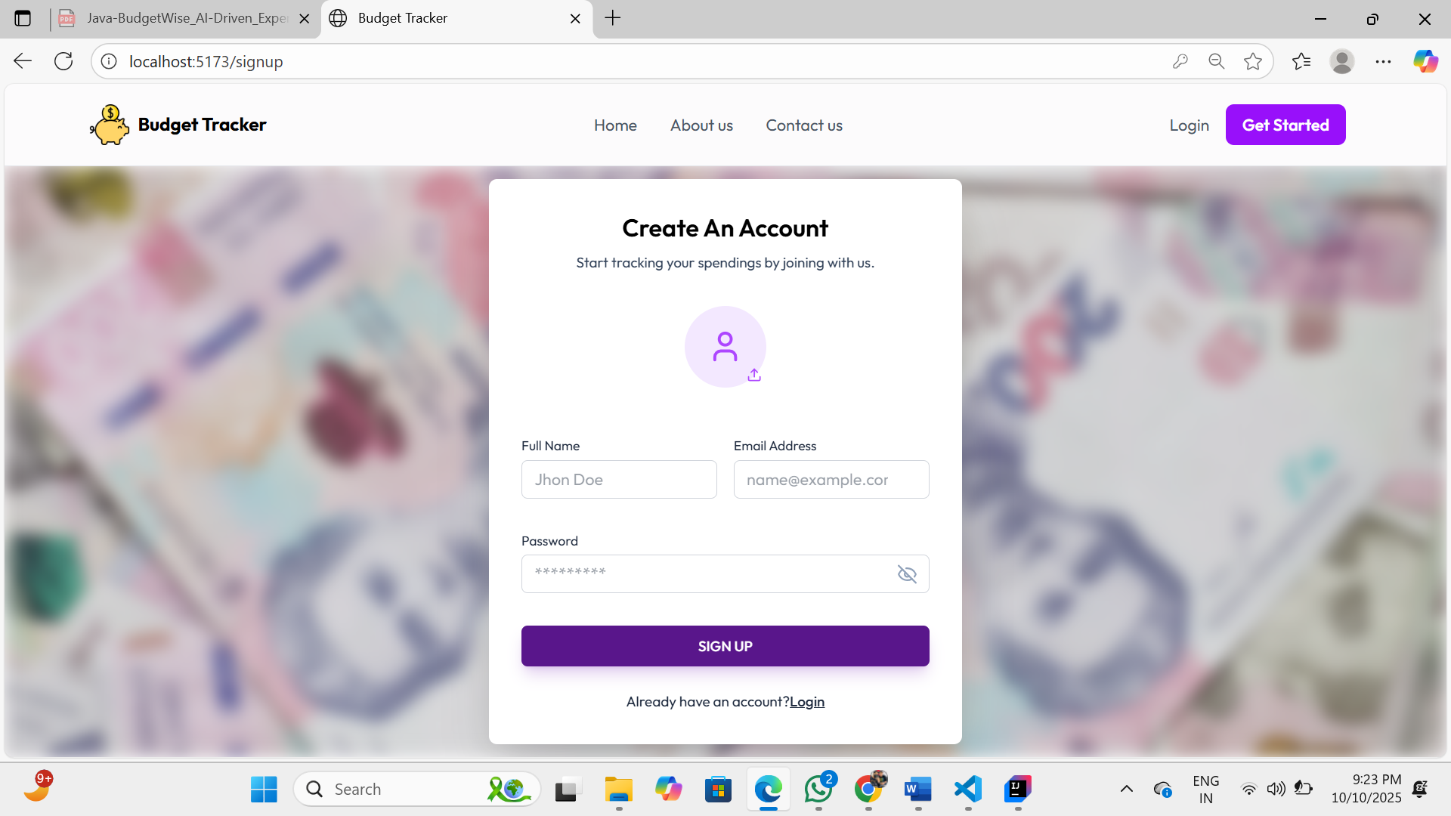

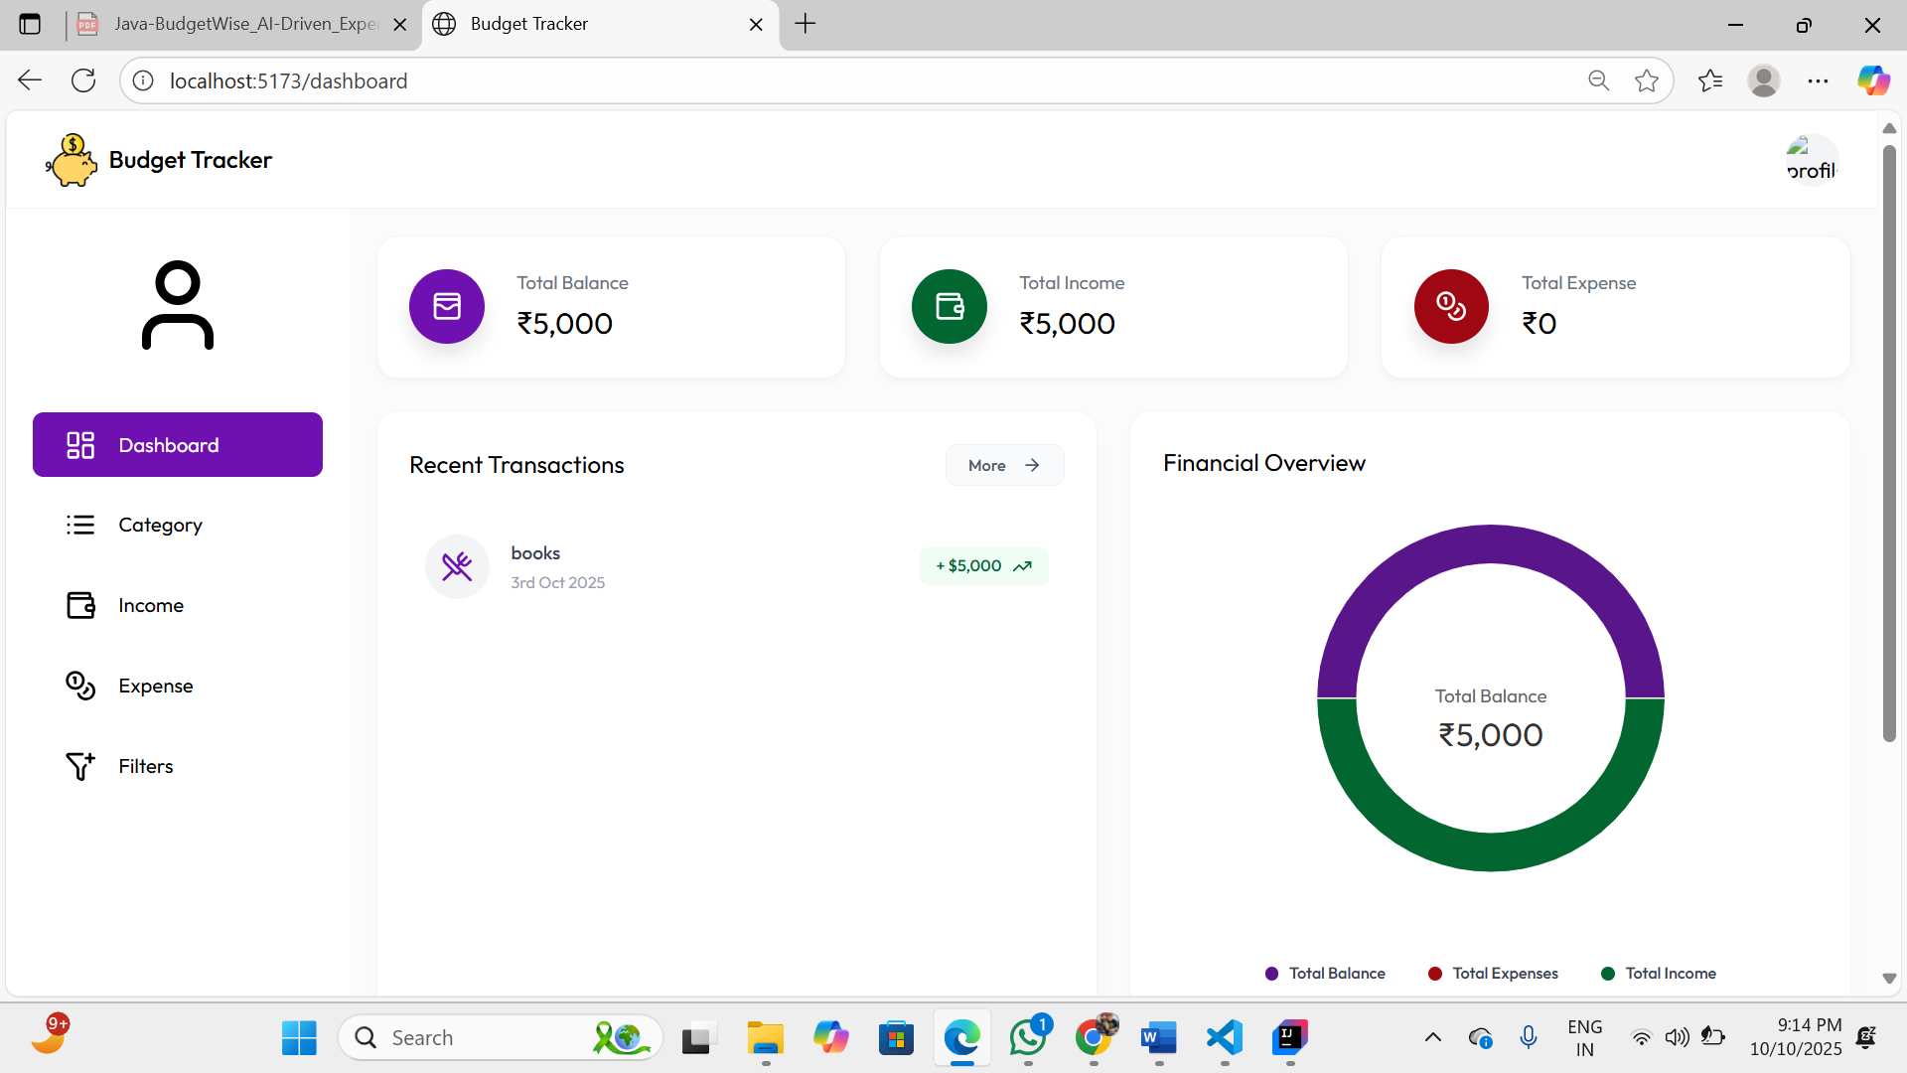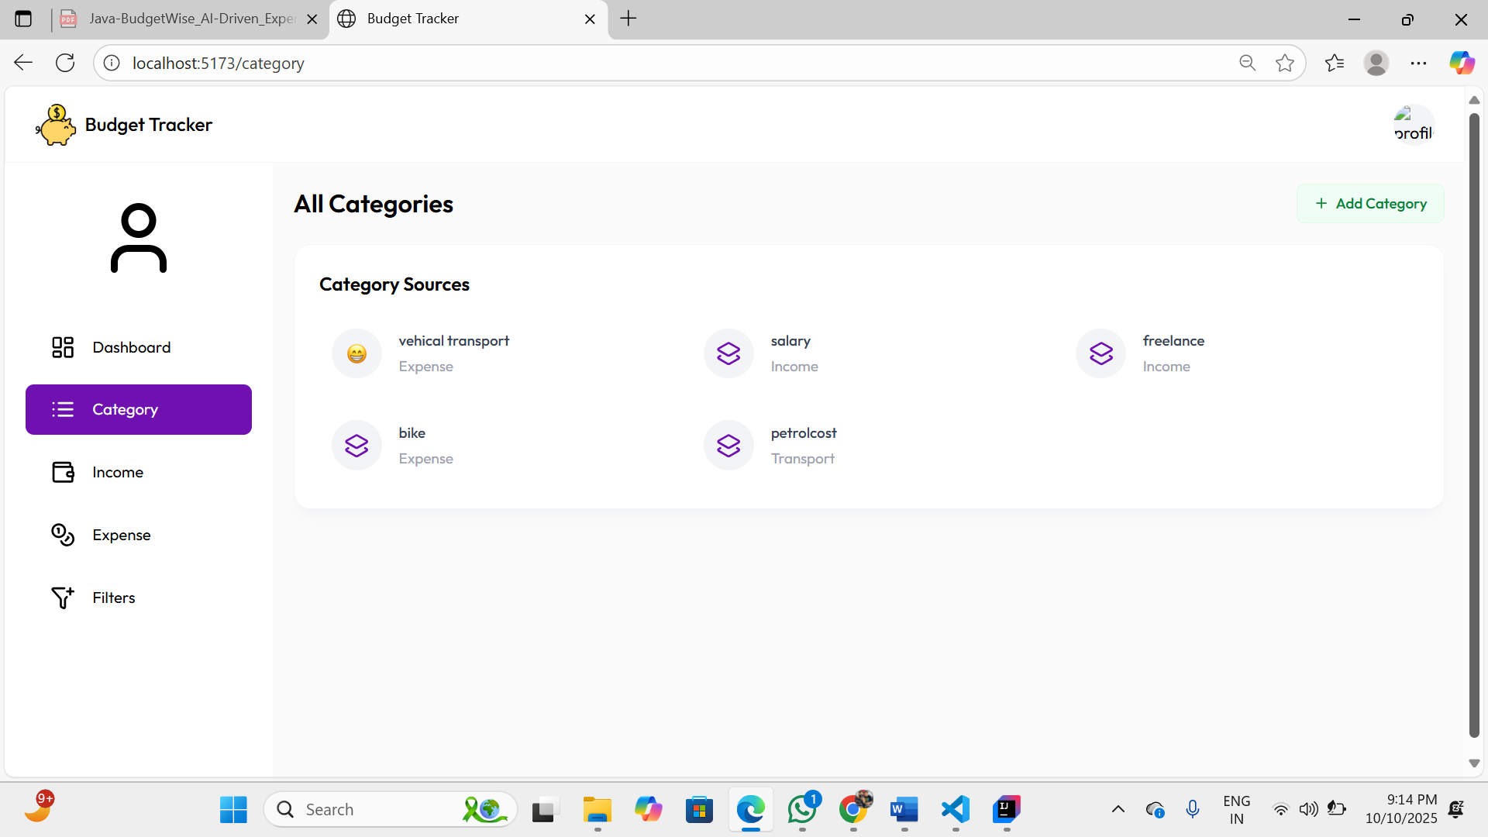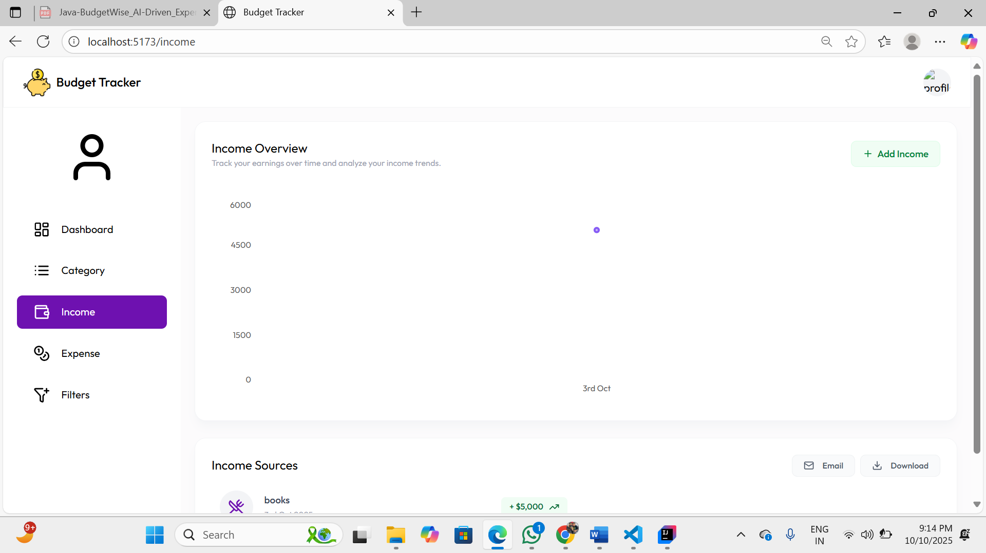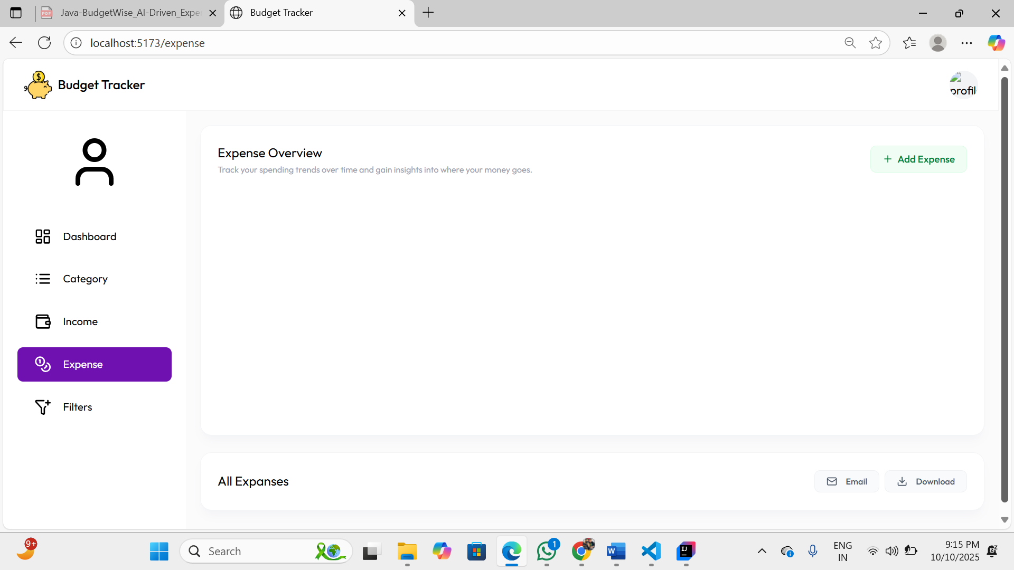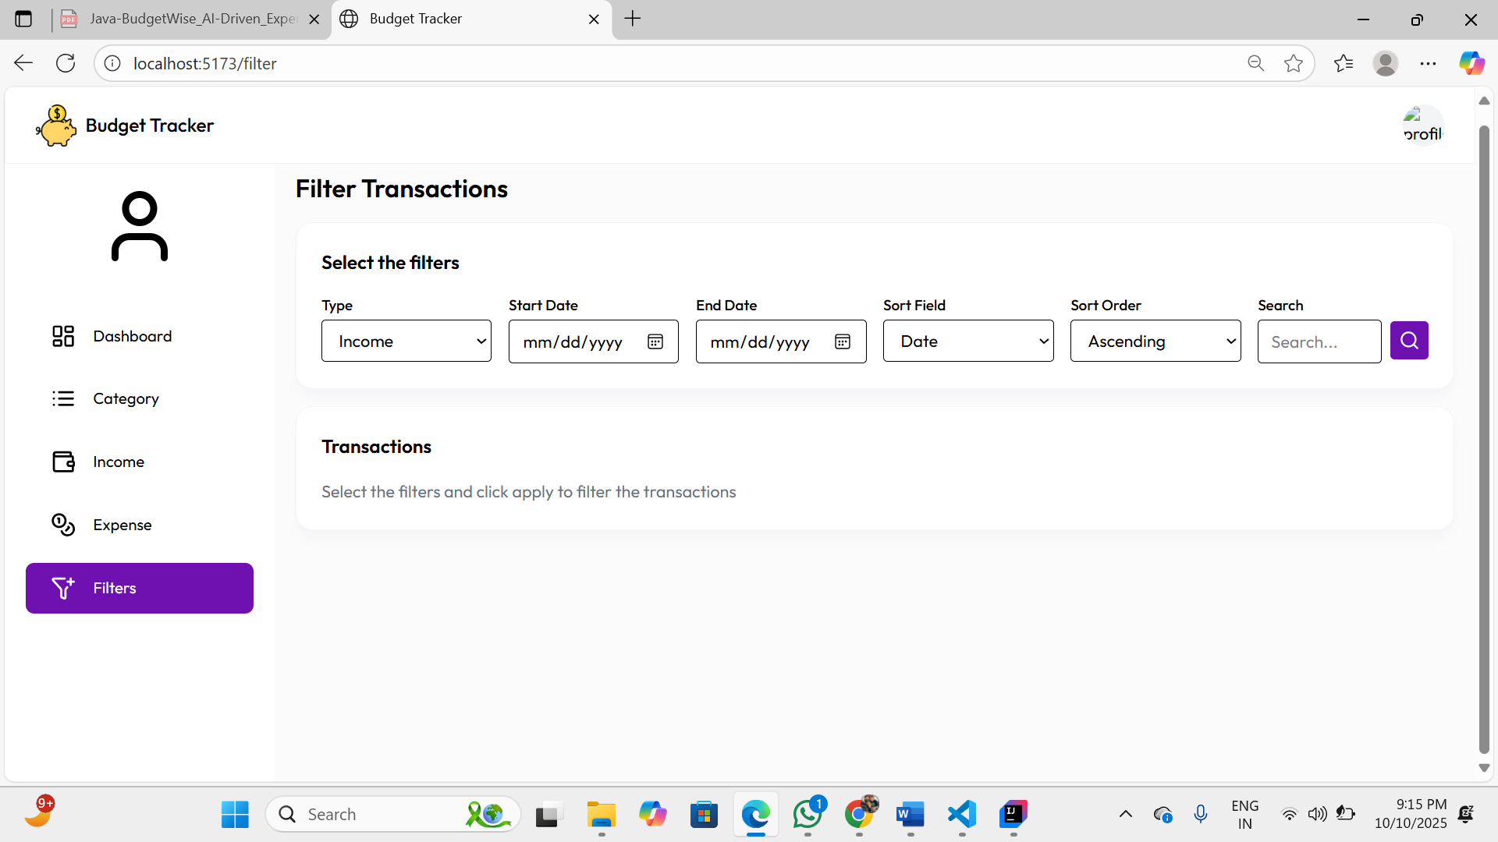

7. Challenges Faced
While the project progressed smoothly, we encountered a few common technical challenges:
- Data Security: Implementing the JWT-based authentication required careful planning to ensure user data was secure and that role-based access control was correctly enforced. We resolved this through rigorous testing and by following security best practices.
- UI/UX for Data Visualization: Presenting financial data in a way that is both accurate and easy to interpret was a challenge. We iterated on several designs for the charts and graphs to find the most intuitive layout.
- Third-Party API Integration: Handling different authentication protocols (OAuth) and API limitations and Ollama AI, which required dedicated research and troubleshooting.

8. Learnings & Skills Acquired
This internship was an immense learning experience. Key skills and knowledge gained include:
- Technical Skills: Gained hands-on experience in full-stack development, including Java for backend logic, implementing REST APIs, JWT for security , using Axios for front-end to back-end communication, and database schema design.
- Project Management: Learned to work effectively within a team, follow a structured timeline, and deliver on weekly milestones.
- Problem-Solving: Enhanced our ability to debug code, troubleshoot integration issues, and find effective solutions to technical challenges.
- Domain Knowledge: Developed a deeper understanding of personal finance management principles, including budgeting, expense tracking, and savings strategies.

9. Testimonials from team

This internship was a fantastic opportunity to apply our academic knowledge to a real-world project. Working on the BudgetWise AI Driven Expense Tracker and Budget Advisor from concept to completion was challenging yet incredibly rewarding. The mentorship and teamwork were highlights of our experience, and we are proud of the functional and impactful application we built together.

10. Conclusion
The 8-week virtual internship culminated in the successful development of a comprehensive BudgetWise AI Driven Expense Tracker and Budget Advisor .The project achieved all its core objectives, delivering a secure, feature-rich platform for users to manage their finances. This experience has been invaluable, providing deep insights into the software development lifecycle and preparing us for future career opportunities in the technology sector.

11. Acknowledgements

We would like to extend our sincere gratitude to Infosys Springboard for providing this virtual internship opportunity. We are also thankful to our mentors (Sanjeev Gone , Kaviyarasan K ) for their continuous guidance, support, and invaluable feedback throughout the project lifecycle. Their expertise was instrumental in navigating challenges and ensuring the project's success.

